### UE20CS301

## Database Management System

## Lab 5 – Joins

Name : Renita Kurian

SRN : PES1UG20CS331

Roll No. : 13

1. Update price of the ticket.

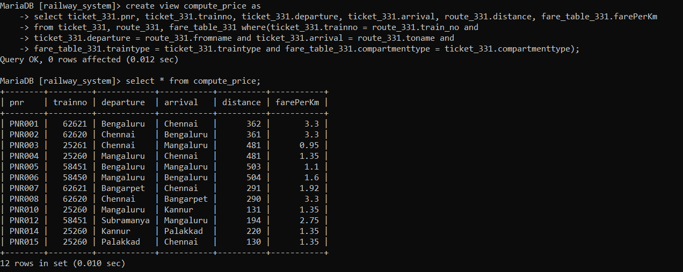

2. Retrieve the all stations along route of the Trains along with the distance between the stations

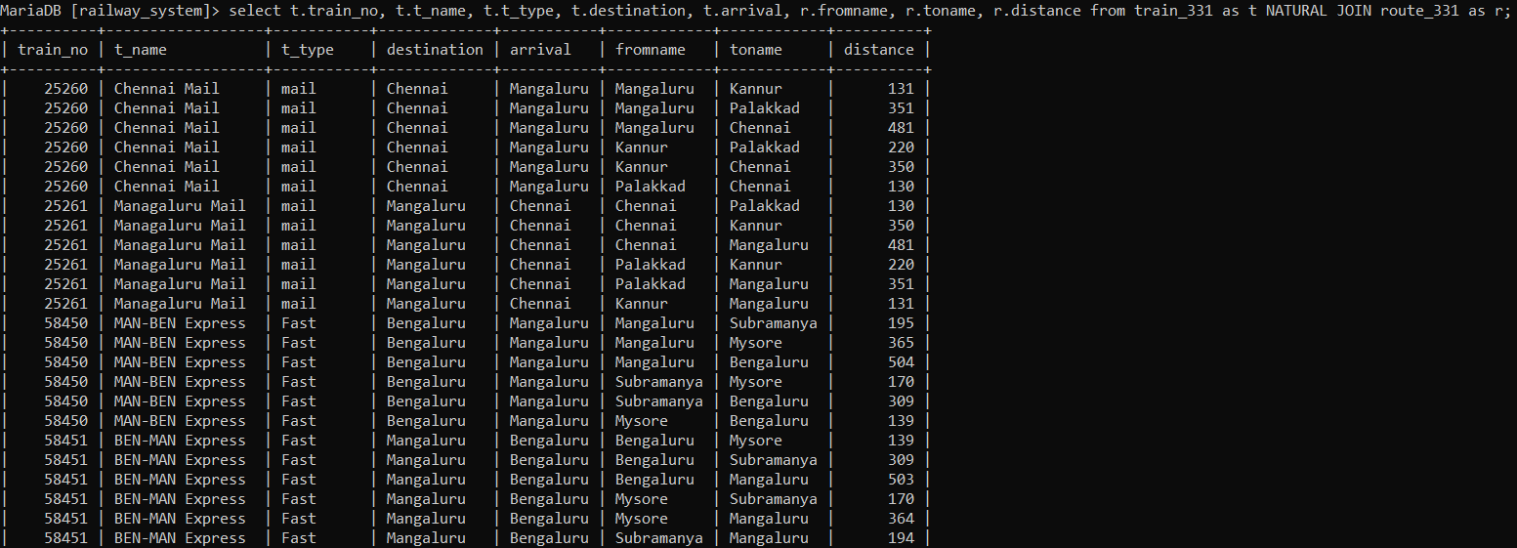

3.Retrieve the Train no of train which is leaving Bengaluru and arriving at Chennai with compartments availability greater than 10

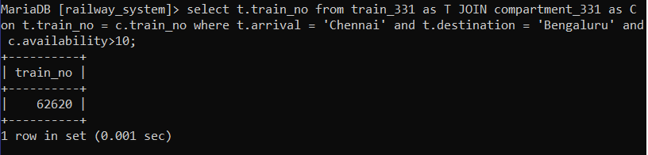

4.Retrieve first and last name of users who have booked a ticket with price greater than 500

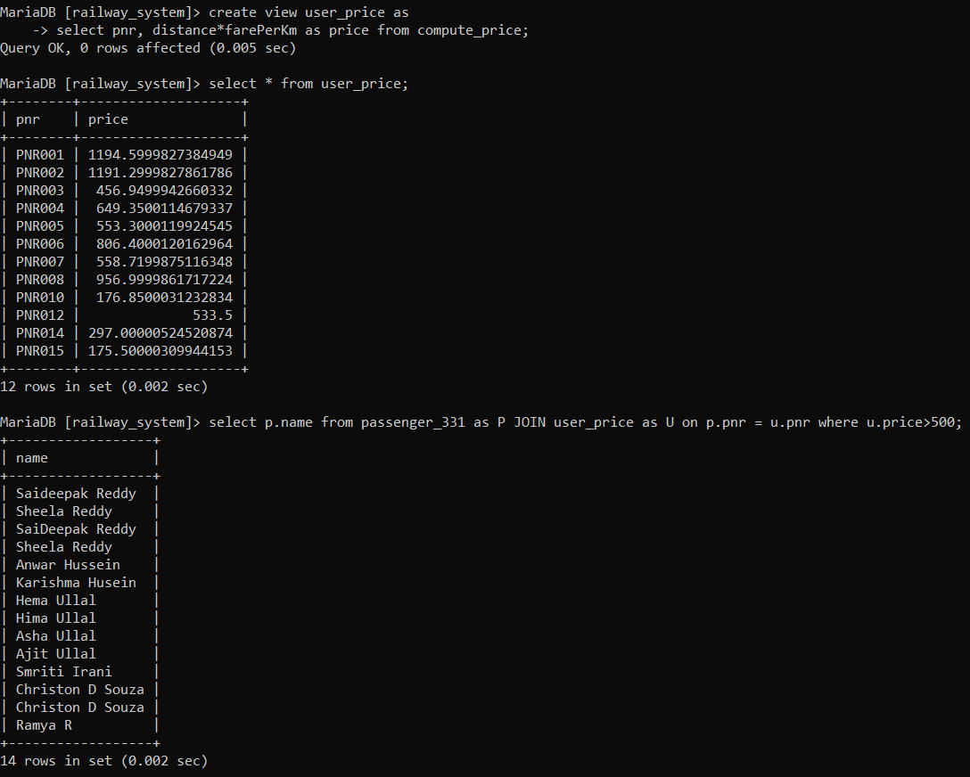

5. Retrieve the first name, last name, DOB and ticket PNR if they’ve bought it for all users.

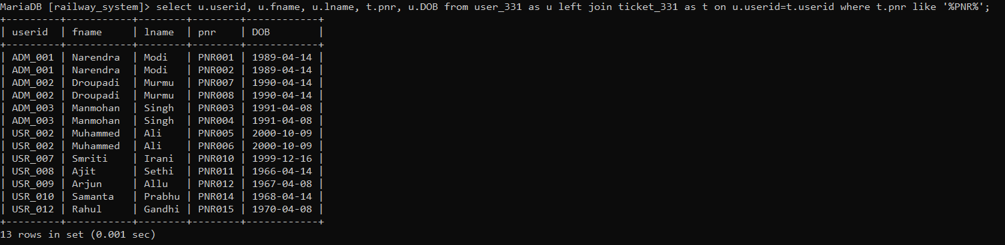

6. Retrieve the first name, last name,of the Users who have not bought a ticket.

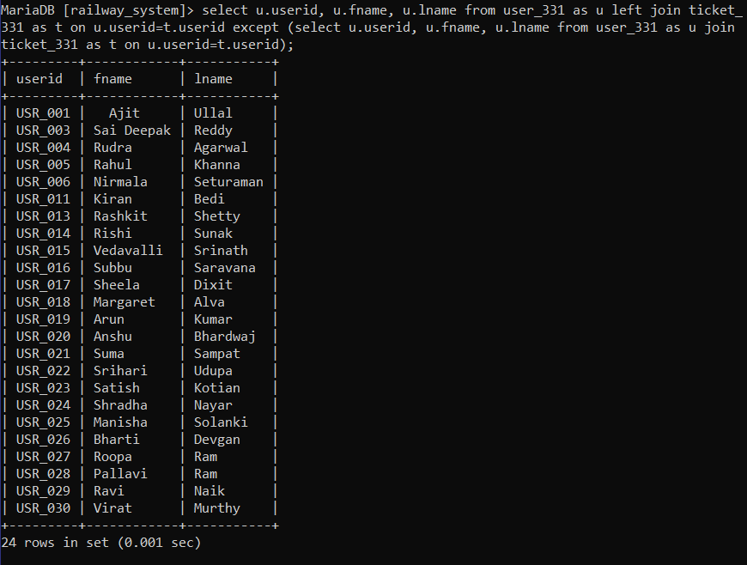

7. Retrieve the ticket PNR, Train number, travel date and along with all users first name and last name.

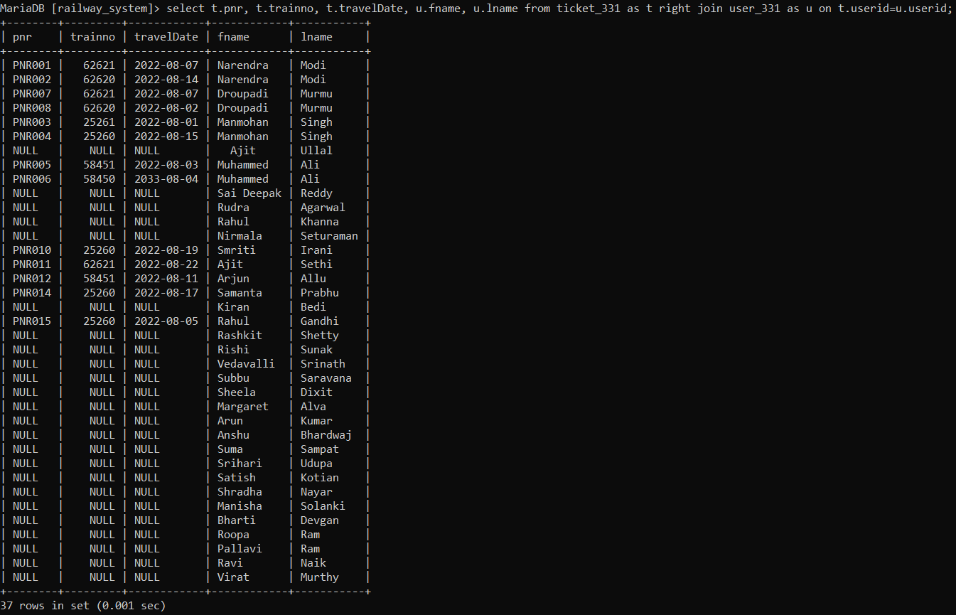

8. Retrieve the user id if they’ve traveled in a train along with train id and name of all trains

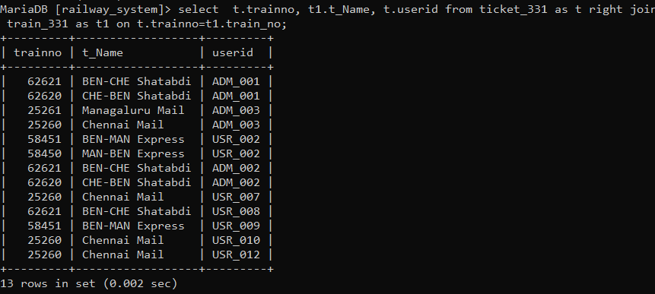

9. Retrieve the train no and name of trains whose destination is not Mangaluru and distance is not less than 100km and departure time is not 8:30:00 PM

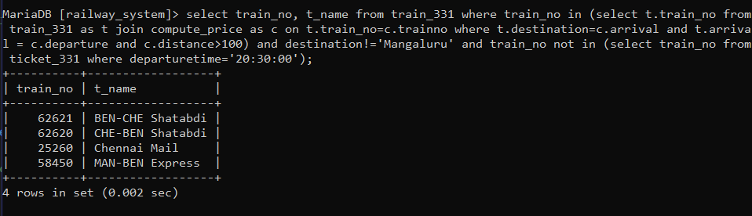

10. Retrieve the User ID who has spent more ticket price than the average ticket price

